Name: _____________________________________________________________________________
Complete each problem. Show ALL work on this paper or a sheet of notebook paper (and attach) for credit to be given. This review must be turned in by Monday, August 8th.
Addition, Subtraction, Multiplication, and Division of Decimals– Round each problem to the nearest hundredth if necessary.
1. 8.27 + 209.8 = ______ 2. 12.45 – 5.8 = ______

3. 199.7 – 145 = ______ 4. $12 ● 5.1$ = _________

5. $16.5 ● 4.2$ 6. $0.6 ÷0.3$

Solve -Write your answer in simplest form.
7. $8-6\frac{1}{3}$ 8. $\frac{1}{3}+\frac{1}{2}$ 9. $\frac{1}{2}+\frac{1}{6}$

10. $\frac{3}{10}-\frac{1}{5}$ 11. $\frac{2}{7} ● \frac{1}{3}$ 12. $5\frac{1}{5} ● 2\frac{1}{6}$

13. $5 ÷ \frac{1}{2}$ 14. $5\frac{1}{5}÷2\frac{1}{6}$

SOLVING EQUATIONS
Step 1: Use the inverse operation to isolate the variable.
Step 2: If a variable is multiplied by a fraction, multiply both sides by the reciprocal to cancel terms.
Step 3: Follow the order of operations backwards to isolate the variable.

15. x – 5 = 12 16. 4x = 12 17. $\frac{x}{5}$ = 10

18. x + 12 = 56 19. 0.2x = 12 20. $\frac{4}{7}x=12$

SOLVING EQUATIONS (Show your work – use another piece of paper, if you need more room)
Step 1: Distribute (if needed).
Step 2: Combine like terms (if needed).
Step 3: Follow the order of operations backwards to isolate the variable.

21. $5\left(x-4\right)=20$ 22. $7x-5x+2=8$ 23. $-4m+7=6m-3$

24. $2\left(x-4\right)=3x-8$ 25. $5x-2x+8=2+6x+6$ 26. $\frac{1}{2}x-3=\frac{2}{3}(x-1$)

INTEGERS: Show your work – use another piece of paper, if you need more room)
To Add Integers: First, rewrite the problem so that there are no double signs. If both numbers have the same sign, keep the sign and add the numbers. If both numbers have opposite signs, subtract the numbers and keep the sign of the larger absolute value.
Examples: –4 + 3 = –1 5 + 2 = 7 –6 + –4 = –10 7 + –2 = 5
To Subtract Integers: First rewrite the problem so that there are no double signs. If the signs are the same in front of both numbers, then keep the sign and add the numbers. If the signs are different, subtract the smaller number from the larger number and keep the sign of the larger absolute value number.
Examples: 5 – 7 = –2 –8 – 2 = –10 5 – –2 = 5 + 2 = 7
To Multiply or Divide: Multiply or divide the numbers, then use the following criteria to choose the appropriate sign: multiplying or dividing two same signs results in a positive number. If you multiply or divide with two different signs (a positive and a negative), the result is a negative number.
Examples: –7$÷$ –1 = 7 6(–3) = –18 –5$∙$–3 = 15

27. 5 – 7 28. 5 $∙$ 7 29. 8 $÷$ –4 30. –1 + –6

31. –5 $∙$–8 32. 6 – 2 33. –12 $÷$ –3 34. –10 $∙$ 6

Directions: Graph each coordinate on the coordinate plane.
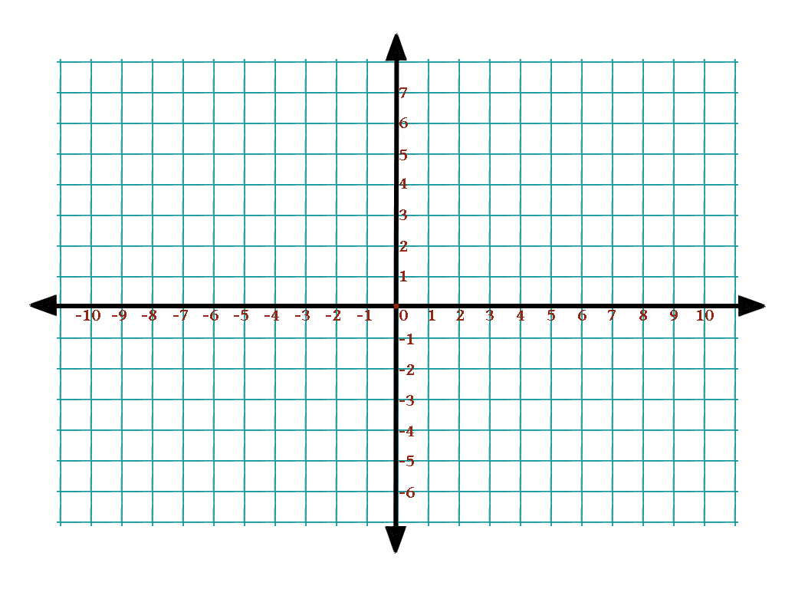
Example: Z(-6, 7)
Z(-6, 7)
36. A($-4,5)$
37. B($-2, -6)$
38. C(3, 7)
39. D($-10, 1)$
40. E($-3.5, -1.5)$
41. F(7, 4)
42. G(8, $-1)$
59. H($-\frac{3}{2}$, 5)60. I(0, 8)

Checklist:
- I answered every question.
- I showed all my work.
- My work is attached if I completed it on a separate sheet of paper.
I understand that my child must show their work and attach it here in order to be given credit for this assignment.

________________________________________________ ___________________________
Parent signature Date

